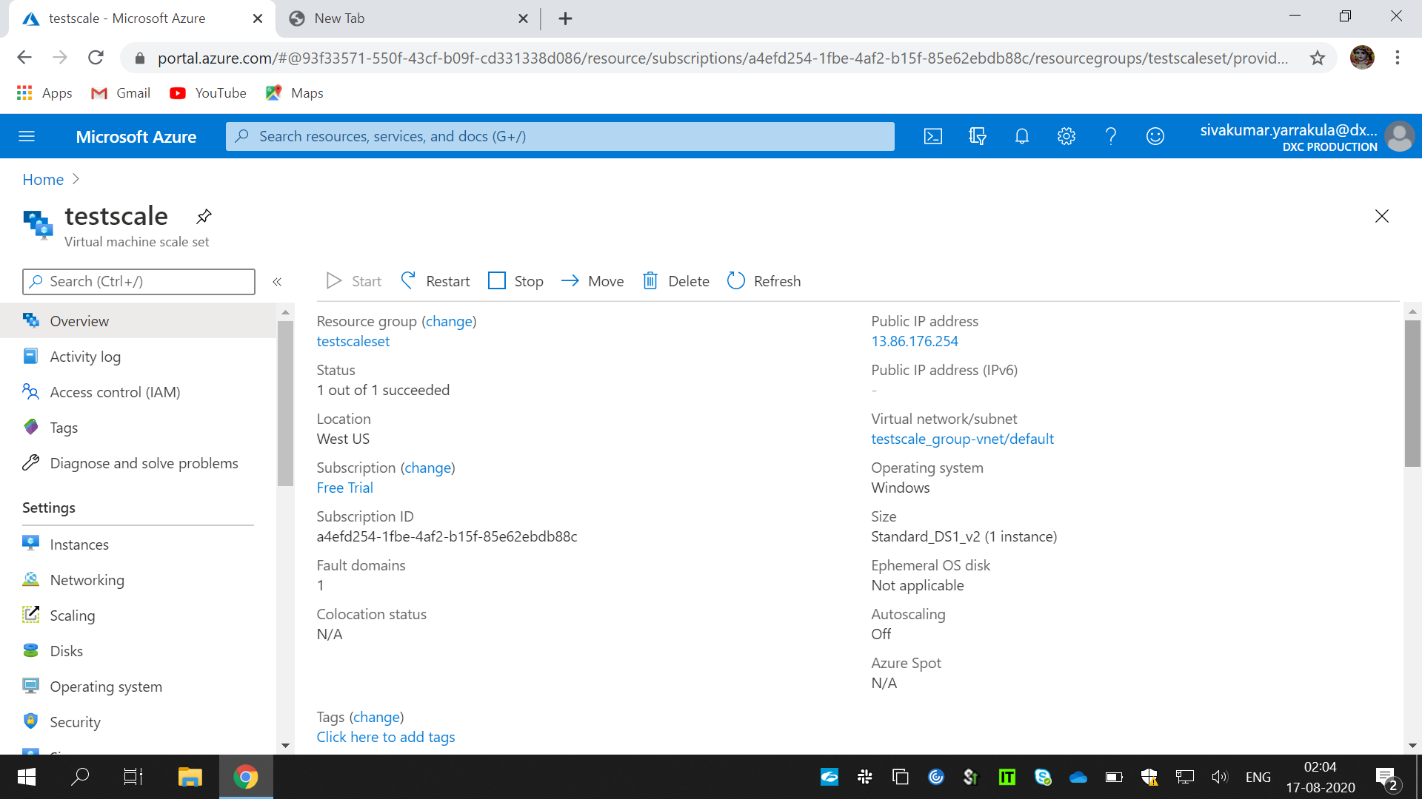

1.Created a scale set with windows os.

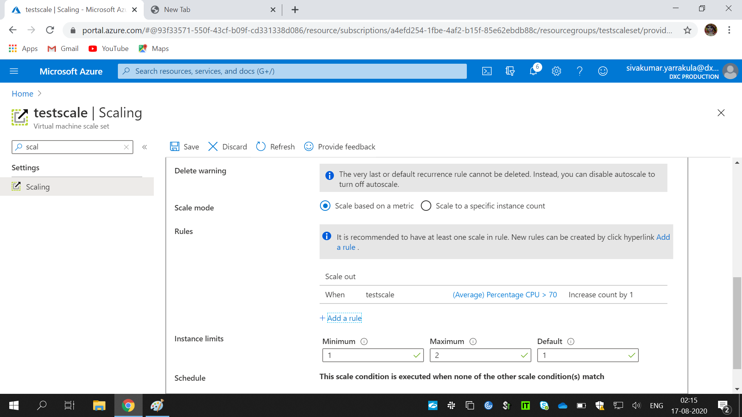

2. Scale out rule using cpu percentage of 70 threshold.

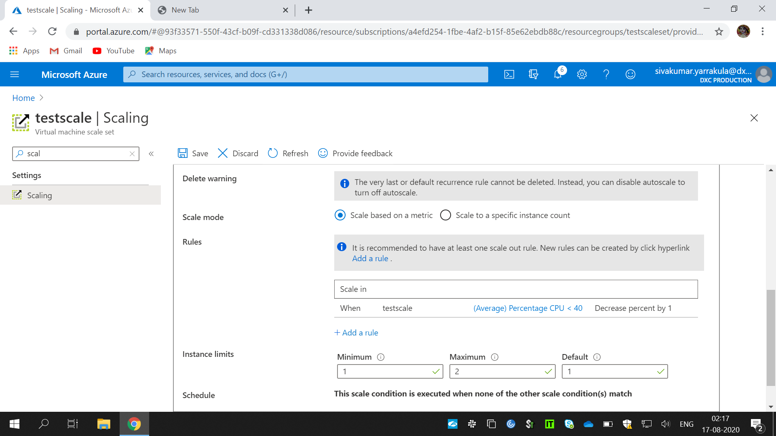

3. Scale in rule using cpu percentage of 40 threshold.

4. created a storage account .

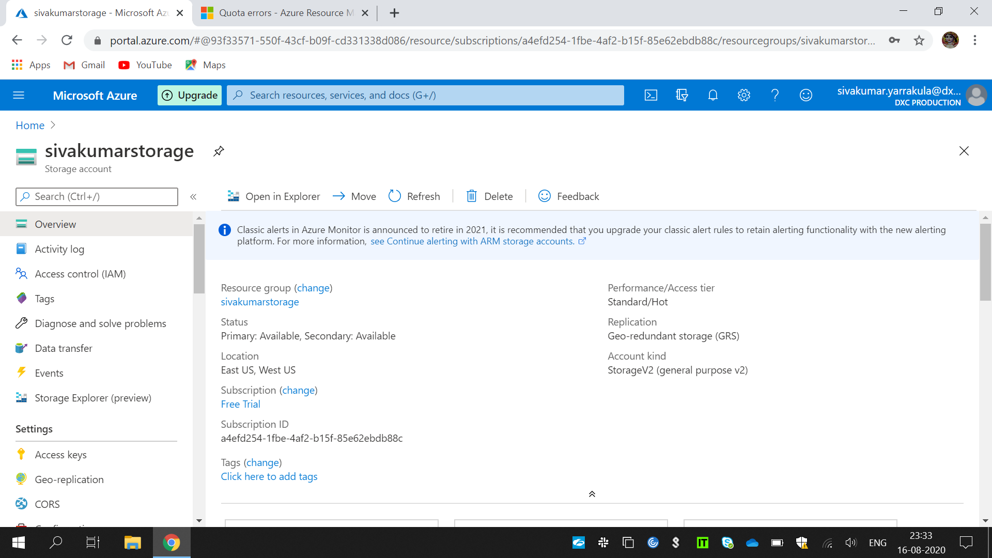

. containers with anonyms access.

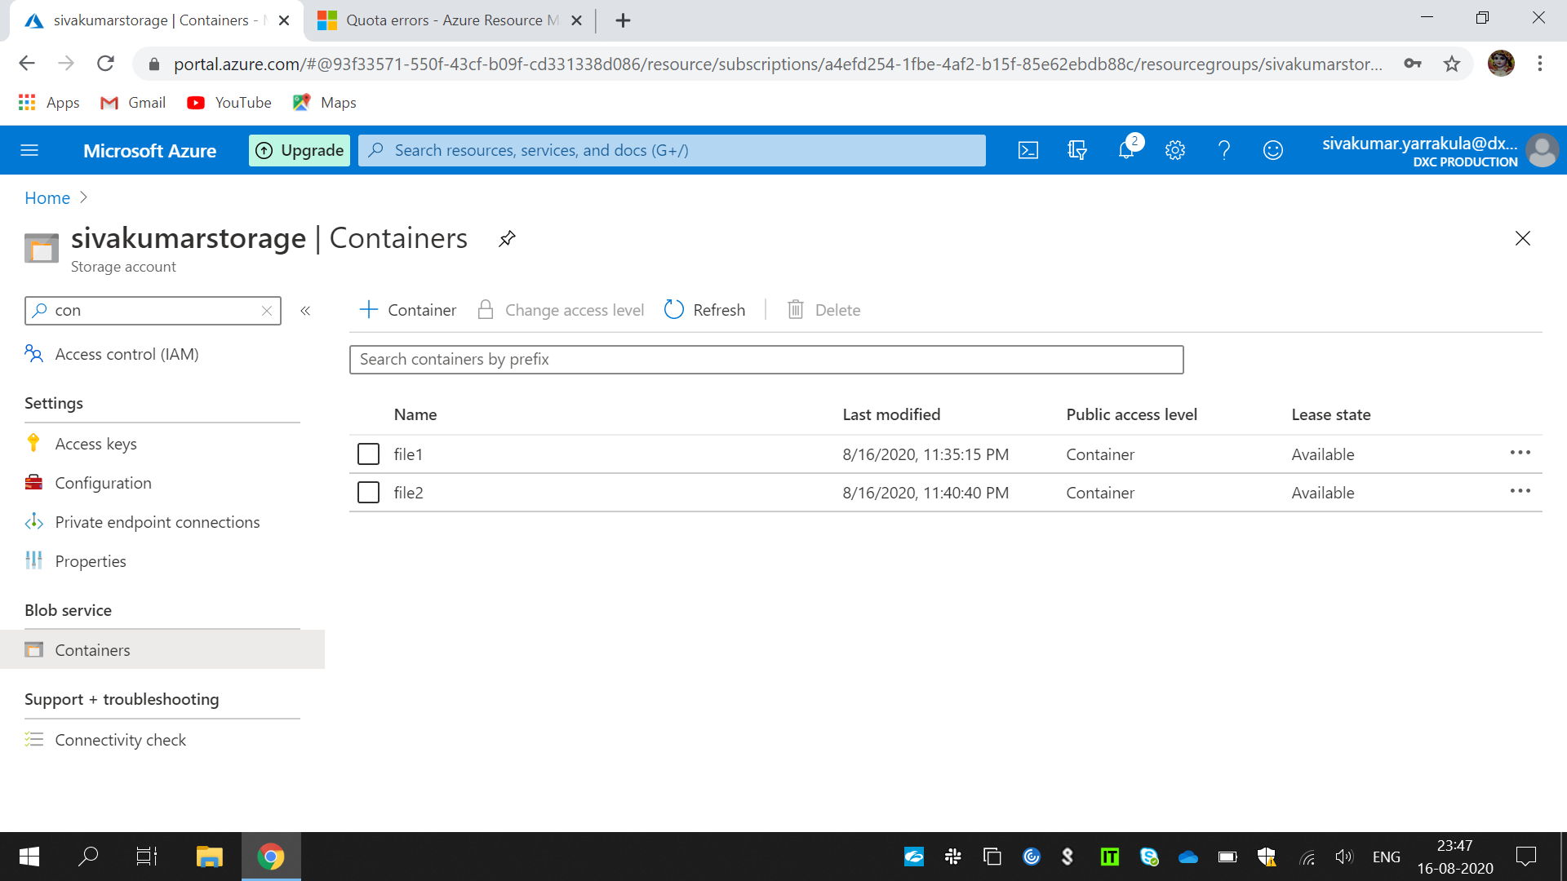

.

.created astatic website in the storage account.

5.Created two virtual machines with no public Ip addresses.

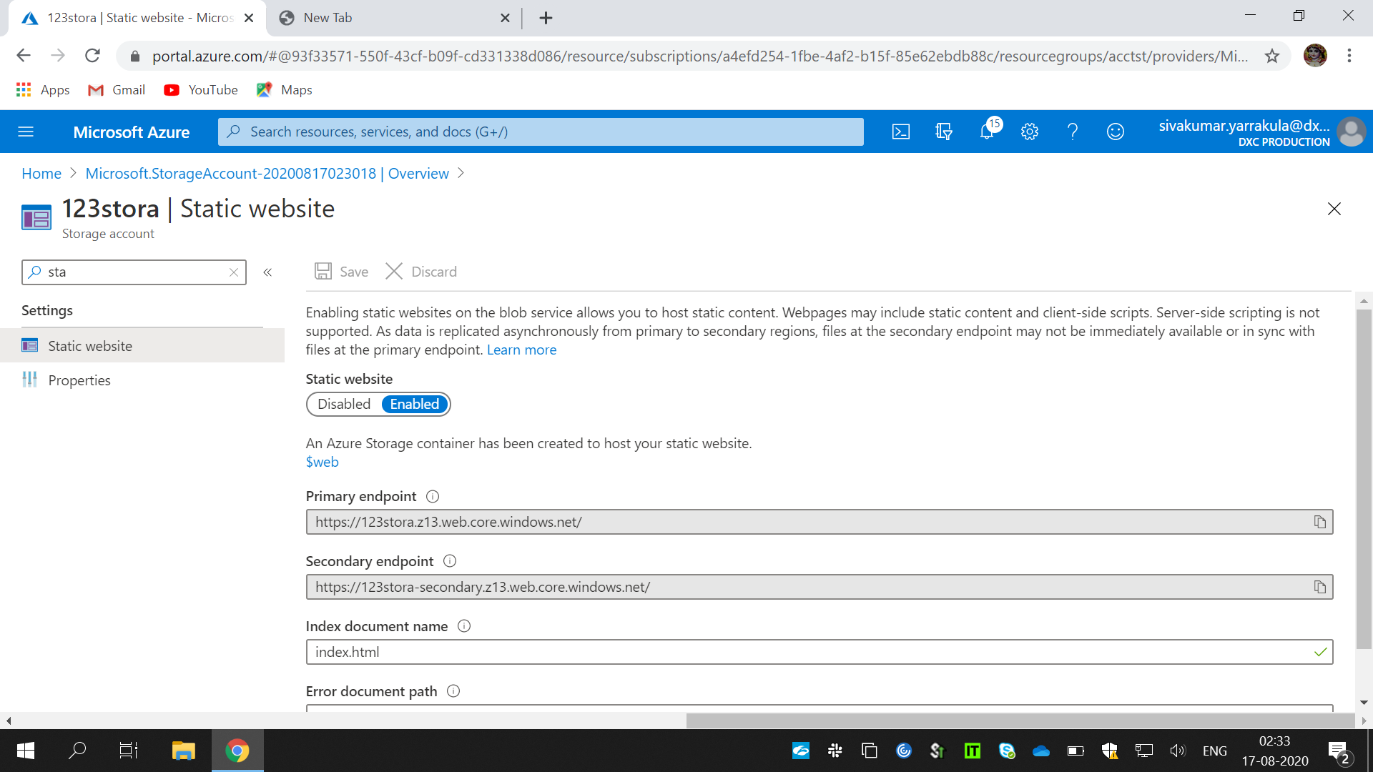

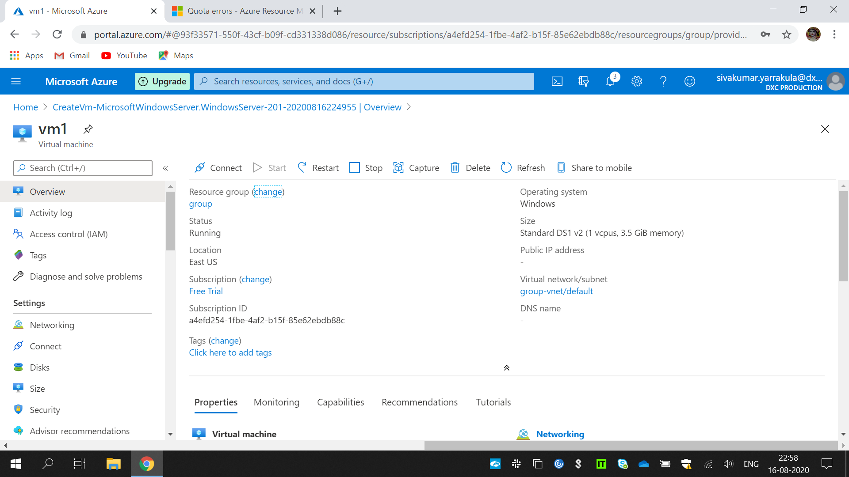

6.Attached the machines to the load balancer and block the 3389 port use 50010.

